Wallace’s
October 19, 2018
nataliewallace@willardschools.net
742-2597 (school office)
or 838-2447 (my cell)


Weekly
Language Arts
This week we learned about the Story Hand during our morning literacy time! This helps students focus on 5 important parts of a story when reading and/or writing. The 5 parts are: characters, setting, and beginning, middle and end. We will start writing about beginning/middle/end in our writing projects more and more. *Ask your child about this.

Math enVisions 2.0
We are working through Topic 4: Compare Numbers 6-10. We use the words more than, less than, greater, fewer, and equal just like we did in Topic 2. *Review at home and continue to count whenever you have any extra few minutes here and there!

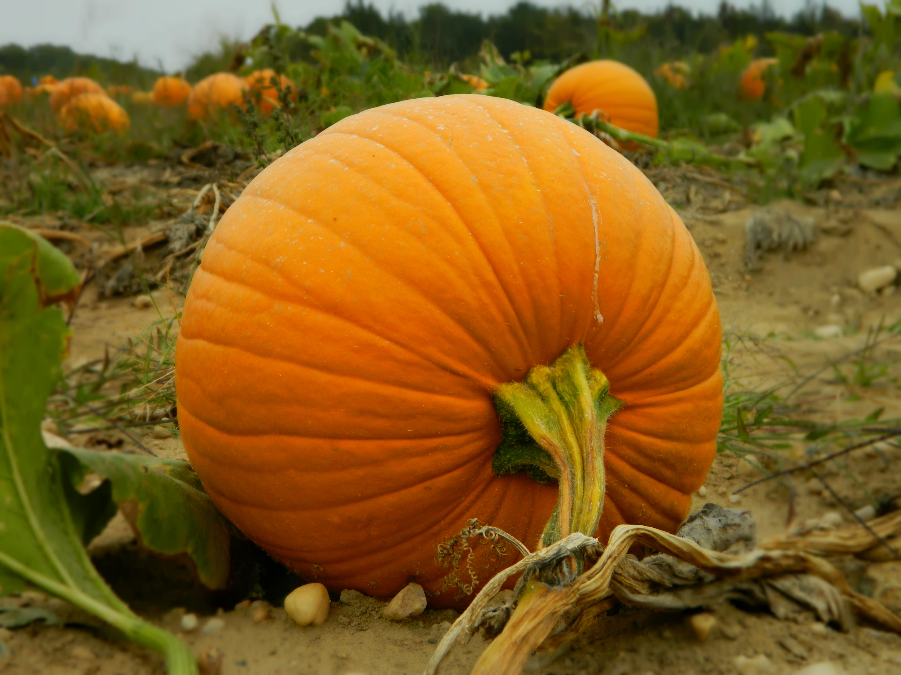
Field Trip/Fall Party
The field trip was a huge success! The kiddos love riding the bus almost as much as the farm itself! Thank you to all the chaperones, and if you weren’t able to attend ask your child ALL about it!
We also had such a fun fall party! Thanks to Kash’s mom, Amy, for all the planning and organizing! I’m glad so many parents were able to attend the party as well; they kids love to see you at school events at this young age especially!

7 Habits of Happy Kids
We finished all 7 habits last week and now we’re starting over and we will review each habit again.
Habit #1: Be Proactive The focus this time about being proactive for kindergarten is about making your own fun or making your “own weather“. Even at this young age they need to be capable of finding things to entertain themselves and not always depend on others’ to do so for them.

*Notes from Natalie*
~I will be out of the classroom Tues nor Thurs.
~Red Ribbon Dress up next week, see note attached.
~Mon Oct. 29-Thurs. Nov 1st- Parent/Teacher Conferences *See note attached*
~Come out Saturday to the Our Town Festival at the WIS! Lots of booths and games! I’ll be at a food booth, The Red Tamale!
~The entire building has been involved in making a Leader In Me video! To complete this task Kindergarten will be wearing GREEN. Please send green shirt to keep at school for a week or so until production is complete, thanks.
~Discuss the items on the newsletter with your child. Write me a short note or a quick email for a Treasure Box Treat!

Wallace’s
Aug. 17, 2018
nataliewallace@willardschools.net
742-2597 (school office)
or 838-2447 (my cell)

Weekly

We had a great first 2 days of school! It takes some time for everyone to learn the
routines and schedules of Kindergarten but, before we know it everything will be
running smoothly! There are also many Willard North Behavior Expectations to
practice and master over the next few days/weeks.
Next week we will start on more of a normal routine for our daily subjects of math, reading, and writing curriculum. The children have been asking to play in the kitchen area, or play with a certain item and I tried to explain that it will take some time to explore everything in the classroom!
*Ask them about the play centers/manipulatives we DID get to.
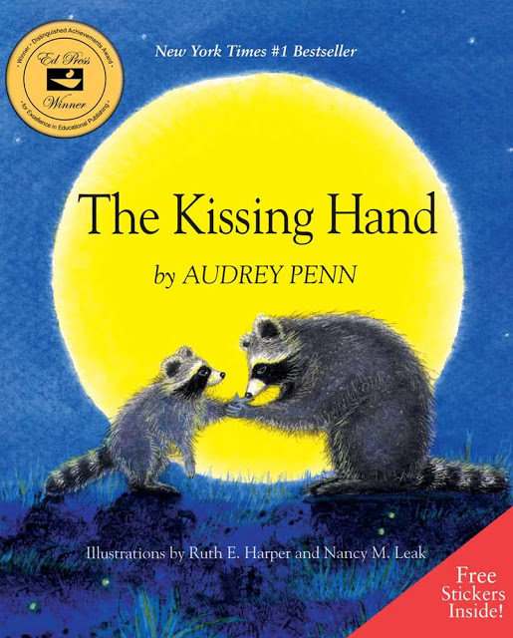
The Kissing Hand
We read a great book called, The Kissing Hand, by Audrey Penn; ask your child about this story. See if they can show you how Chester’s mom gave him a kiss on the palm of his hand & in what manner it reached his heart.

-You may exchange your child’s rest mat for a towel or small blanket and/or you may send a towel or small blanket to go with their mat.
-Let me know if you DID NOT see the snack calendar I sent home at meet the teacher so I can get you another copy.
-Please sign-up for the class group text on Remind... enter this number 81010 text this message @94c422a. You may not reply to those texts but it’s a great way for me to communicate something quickly to you. And send photos!

*Discuss the things on this newsletter with your child, write me a short note, or send a quick email so your child will receive a Treasure Box Treat!

